Software Requirements Specification

for

Busy Bee Calendar
Version 1.0 approved
Prepared by Benjamin Tanguay, Jonathon Mathieu, Jackson Hooper, Mark Scully
Team Bee
2/19/2026
Table of Contents
Table of Contents ii
Revision History ii
1. Introduction 1
1.1 Purpose 1
1.2 Document Conventions 1
1.3 Intended Audience and Reading Suggestions 1
1.4 Product Scope 1
1.5 References 1
2. Overall Description 2
2.1 Product Perspective 2
2.2 Product Functions 2
2.3 User Classes and Characteristics 2
2.4 Operating Environment 2
2.5 Design and Implementation Constraints 2
2.6 User Documentation 2
2.7 Assumptions and Dependencies 3
3. External Interface Requirements 3
3.1 User Interfaces 3
3.2 Hardware Interfaces 3
3.3 Software Interfaces 3
3.4 Communications Interfaces 3
4. System Features 4
4.1 System Feature 1 4
4.2 System Feature 2 (and so on) 4
5. Other Nonfunctional Requirements 4
5.1 Performance Requirements 4
5.2 Safety Requirements 5
5.3 Security Requirements 5
5.4 Software Quality Attributes 5
5.5 Business Rules 5
6. Other Requirements 5
Appendix A: Glossary 5
Appendix B: Analysis Models 5
Appendix C: To Be Determined List 6

Revision History
Name | Date | Reason For Changes | Version

Introduction

Purpose

This document is a requirements specification for the first release of Busy Bee Calendar. The document contains specifications for various systems, including task management (create, edit, and delete tasks), task/event prioritization, and a contact/help page.

Document Conventions

This Document was created based on the IEEE template for System Requirements Specification Documents.

Intended Audience and Reading Suggestions

This document is for the following intended audiences: product manager, developers, designers, and users. The purpose of this document is to provide a detailed description of our product. Users should read sections 1 and 2 to have a better understanding of the general purpose and use of the application. The rest of the sections focus on the more technical details and are more focused on those working on the application.

Product Scope

The Busy Bee Calendar application is a scheduling and task management tool designed to help students and general users organize their time efficiently. The system allows users to create tasks, schedule events, view deadlines, and receive reminders for important activities.
The primary goal of the application is to improve productivity through providing a simple and intuitive interface for managing daily schedules. By putting tasks and events into one platform, the Busy Bee Calendar application helps users stay organized and manage their responsibilities more effectively.

References

There are currently not any other documents or web addresses referred to in this current SRS documentation; this will most likely change as the project progresses.

Overall Description

Product Perspective
Busy Bee Calendar app is a new mobile application designed to help users organize tasks, deadlines, and events all in one place. The system is intended to simplify time management by providing a centralized scheduling system. The Busy Bee Calendar is a new product and is not a direct replacement for any existing software. Rather than replace existing software like Google or Apple Calendar, you can transfer your existing information. This app is meant to create a more user-friendly interface.

Product Functions
Functions:
- Create task/event
- Edit or delete task/event
- View task/events in calendar format
- Set notifications/reminders
- Mark task as completed
- Categorize tasks/events based on importance level
- Store the users information for the next time they log in

User Classes and Characteristics
The primary user class for the Busy Bee Calendar application is students. Students will use the system to manage academic schedules, assignments, and personal tasks. They are expected to interact with the application frequently throughout the day to track deadlines, class events, and reminders. This group represents the highest priority user class, as the application was designed primarily to support student time management.

The second user class is general users. These users may include individuals who want to manage personal events, appointments, or daily tasks. While they use many of the same features as students, they are expected to access the application less frequently and may rely on it mainly for general scheduling rather than academic organization.

The lowest priority user class is administrators. Administrators are responsible for maintaining the system, managing updates, and addressing technical issues related to the application. These users typically require a higher level of technical knowledge but interact with the system less frequently than regular users.

Operating Environment

The software will operate within a web browser of any of the following devices, Smartphones (Apple, Android, etc.), Windows, and Mac. Will work on the latest operating system updates for these devices. Since it will be accessed via the web browser, no additional or supplementary software or applications will be required to use our software.

Design and Implementation Constraints
So far, there are no known limitations or requirements; this might change as the project progresses.

User Documentation
The Busy Bee Calendar application will provide basic user support and documentation to assist users in navigating and using the system. A Help and Support section within the application will allow users to contact administrators to report issues, ask questions, or request assistance.

In addition, the application will include simple in-app guidance, such as clear button labels, intuitive navigation, and brief instructions where necessary to help users understand how to perform common tasks like adding, editing, or deleting events. Documentation and support will be delivered directly through the mobile application interface.

Assumptions and Dependencies

Assumptions:
- The application assumes users will access the system using a compatible device such as a smartphone.
- The system assumes that users have reliable internet access for syncing events, storing data, and receiving notifications.
- The application assumes users have basic knowledge of using mobile apps or digital calendars.
- The system assumes that the user’s device supports push notifications for reminders and alerts.

Dependencies:
- Based on our current implementation, we have no dependency on other software. This will most likely change if we use libraries.

External Interface Requirements

User Interfaces
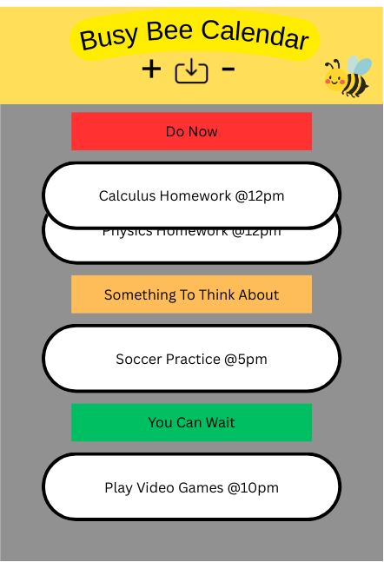
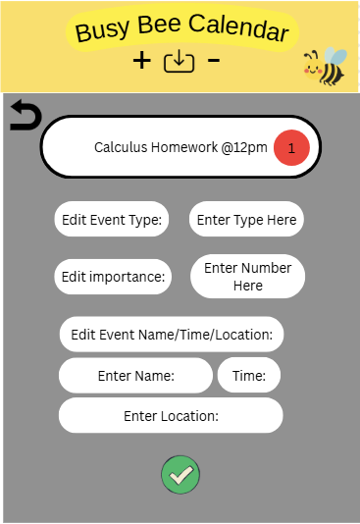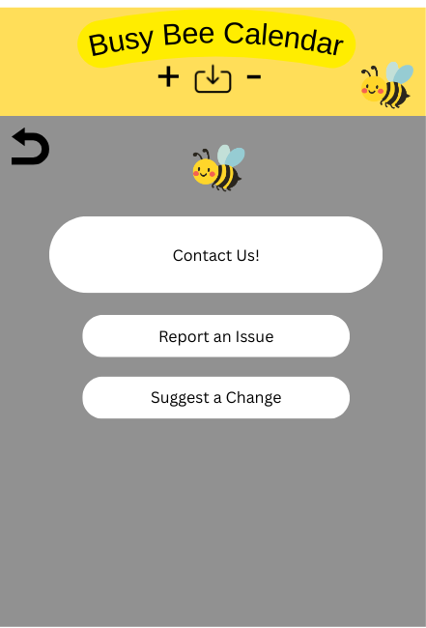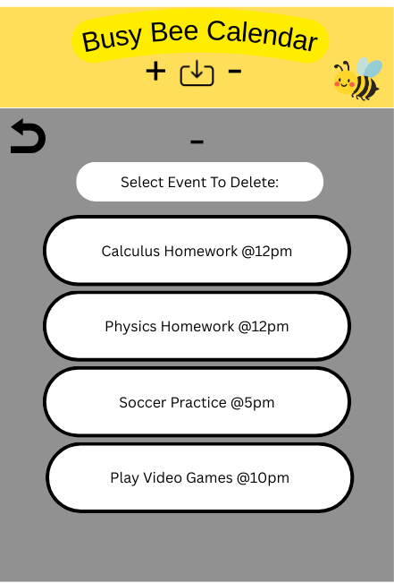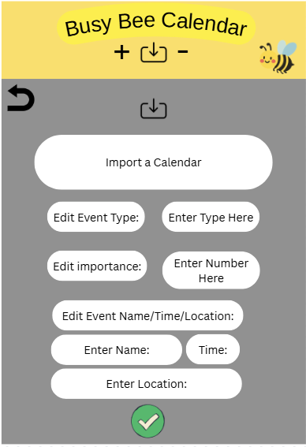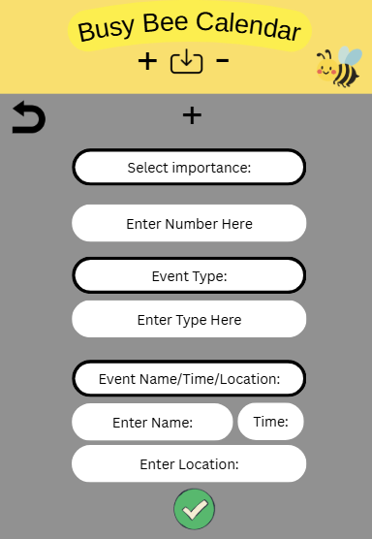
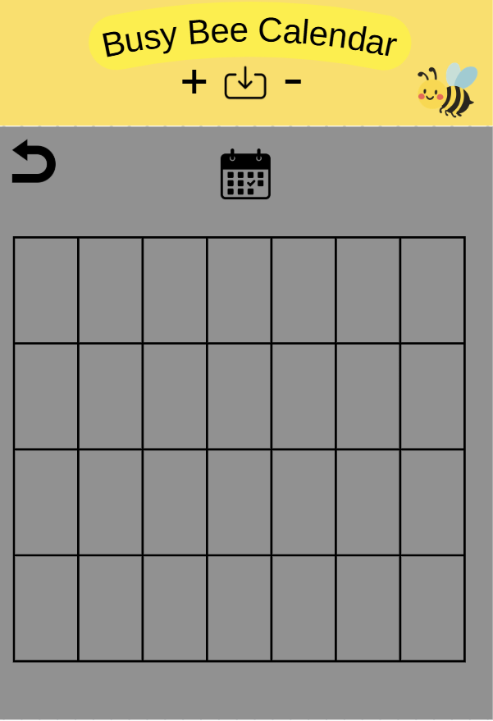

The Busy Bee Calendar software product provides a mobile-first graphical user interface (GUI) designed for smartphones. The interface emphasizes touch interaction, simple navigation, and clear visual organization. The layout is optimized for smaller screens, portrait orientation, and
one-handed use. Detailed mockups and layout measurements are documented separately in the User Interface Specification.

Overview of User Interface Design

The system uses a consistent visual theme across all screens. A persistent top header bar appears on every screen and includes the application title, Busy Bee Calendar, along with touch-friendly
navigation icons. These icons include a back arrow to return to the previous screen, an Add (+) button to navigate to the Add Event screen, an Import/Upload icon to access the Import Calendar screen, and a Delete (–) button to navigate to the Delete Event screen. Icons are sized appropriately for finger tapping and spaced to prevent accidental selection. Bee-themed branding elements are included to maintain product identity.

The color scheme includes a yellow header for branding consistency and a gray background workspace. Events are color-coded by importance level: red indicates high importance (“Do Now”), yellow indicates medium importance (“Something to Think About”), and green indicates low
importance (“You Can Wait”). Buttons are rounded rectangles with large tap areas and consistent spacing. A green checkmark button is used for confirmation actions such as saving or submitting changes.

Software Components Requiring a User Interface

The software components that require a mobile user interface include the Main Dashboard, Add Event interface, Edit Event interface, Delete Event interface, Import Calendar interface, and Contact/Support interface.

Main Dashboard

The Main Dashboard displays categorized events based on importance level. Events are grouped visually under Do Now, Something to Think About, and You Can Wait sections. Each event appears as a large, touch-friendly button. Users can scroll vertically through events. Selecting an event opens the Edit Event screen. The header provides quick access to Add, Delete, and Import functions through touch icons.

Add Event Interface

The Add Event screen allows users to create a new event. Users select the importance level using large color-coded selection buttons and enter information, including Event Type, Event Name, Time, and Location. Mobile-optimized input controls are used, such as the device’s native time picker and on-screen keyboard. The Event Name field is required. A green confirmation checkmark saves the event, while the back arrow cancels the action and returns to the previous screen. If required fields are empty or formatted incorrectly, an error message is displayed directly below the affected field in red text, and the submission is prevented until the error is corrected.

Edit Event Interface

The Edit Event screen allows users to modify an existing event. The selected event is displayed at the top of the screen. Users can update the Event Type, Importance Level, Event Name, Time, and Location using mobile-friendly input fields. Changes are not saved until the confirmation checkmark is pressed. The selected importance level is clearly highlighted.

Delete Event Interface

The Delete Event screen displays a vertically scrollable list of events. Users tap an event to select it for deletion. A confirmation prompt appears before permanent deletion to prevent accidental removal. The confirmation dialog is centered and clearly labeled for mobile
readability.

Import Calendar Interface

The Import Calendar screen allows users to import external calendar data from supported mobile-accessible file sources. An import button initiates the process. If necessary, users may edit event details or reassign priority levels before confirming. The system accepts only supported file formats and displays a clear error message if an unsupported format is uploaded.

Contact and Support Interface

The Contact/Support screen provides options such as Contact Us, Report an Issue, and Suggest a Change. Buttons are large and vertically stacked for easy tapping. This screen ensures users can communicate feedback or request assistance directly from their mobile device.

Calendar View Interface

The Calendar View screen displays events in a mobile-friendly monthly calendar layout. Each day appears as a touch-friendly cell, and dates with events show colored indicators based on importance: red for Do Now, yellow for Something to Think About, and green for You Can Wait. Users can tap a date to view the events scheduled for that day and select an event to open the Edit Event screen. Arrow buttons allow users to move between months, and the current date is highlighted for easy reference.

GUI Standards and Conventions

The interface maintains consistent header placement and navigation layout across all screens. Button shapes, confirmation icons, and color-coded importance indicators are standardized throughout the system. All input fields are clearly labeled and optimized for touch interaction. The design minimizes clutter while ensuring readability on small screens.

Error Message Display Standards

Error messages appear directly below the relevant input field in clear, specific language. Errors are displayed in red text and sized for readability on mobile screens. The system prevents submission until all validation errors are resolved.

Mobile Interaction and Layout Constraints

The header remains fixed at the top of the screen. Content areas are vertically scrollable. All primary actions are reachable within one or two taps. The layout is responsive to accommodate various smartphone screen sizes and resolutions. Touch targets follow mobile usability guidelines to reduce input errors.

Help and Standard Functions

Back navigation is available on every screen. Confirmation is required for destructive actions. Visual feedback confirms successful saves. The Contact/Support option is accessible from the main navigation.

Hardware Interfaces
The Busy Bee Calendar application is designed to operate on modern smartphones and mobile devices. The system interacts with the device’s touchscreen interface for user input and display output. The application also utilizes the device’s internal clock to manage event time and date information.

Optional hardware interactions may include access to local device storage for importing calendar files and accessing uploaded data. The system relies on the smartphone’s standard hardware components, including the processor, display, and storage, but does not require specialized hardware devices

Software Interfaces
The Busy Bee Calendar software operates within a mobile operating system environment, such as Android or iOS. The application uses the operating system’s built-in graphical user interface framework to render screens and handle touch input.

The system may interface with external calendar file formats (such as standard calendar export files) for importing events. Data related to events, including event name, time, location, type, and importance level, is stored and retrieved through the application’s internal data storage system or database.

The application also uses native mobile features such as the device time picker and keyboard for user input.

Communications Interfaces
The Busy Bee Calendar application may use standard internet communication protocols to import external calendar data from supported sources. Communication between the application and external services occurs through standard web protocols such as HTTP or HTTPS.

Data transferred through these communications may include calendar event information such as event names, dates, times, and locations. Secure communication methods such as HTTPS are used to protect transmitted data when external calendar sources are accessed.

Network communication is only required when importing calendar data or accessing online support resources. The application can otherwise function normally without an active internet connection.

System Features

Task Management
4.1.1 Description and Priority

The Task Management feature allows users to create, edit, and delete tasks containing scheduling details and priority levels. This feature forms the core functionality of Busy Bee Calendar.
Priority: High
4.1.2 Stimulus/Response Sequences

Create Task
- The user presses the (+) button.
- The system displays task creation form.
- The user enters task details and selects priority.
- The user presses the confirmation checkmark.
- The system validates inputs and saves the task.
- The system displays the task in the appropriate priority section.

Edit Task
- User selects the edit option.
- The system displays editable task form.
- The user modifies details and confirms.
- System updates task and refreshes dashboard.

Delete Task
- User selects the delete option.
- The system displays selectable task list.
- User selects task and confirms deletion.
- The system removes task and updates dashboard.

4.1.3 Functional Requirements

REQ-TM-1: The system shall allow users to create tasks containing name, date/time, location, type, and priority level.
REQ-TM-2: The system shall validate required fields (task name and date/time) before saving.
REQ-TM-3: The system shall display an error message if required fields are missing or invalid.
REQ-TM-4: The system shall allow users to edit any existing task.
REQ-TM-5: The system shall allow users to delete tasks after confirmation.
REQ-TM-6: The system shall persist tasks across application sessions.

4.2 Priority Dashboard Display

4.2.1 Description and Priority

This feature provides the main dashboard interface that organizes tasks into visual priority categories using color-coded cards.
Priority: High
4.2.2 Stimulus/Response Sequences

- User opens the application.
- The system loads stored tasks.
- The system categorizes tasks by priority.
- The system displays tasks in Do Now, Something to Think About, and You Can Wait sections.
- User scrolls the dashboard to review tasks.

4.2.3 Functional Requirements
REQ-PD-1: The system shall display tasks grouped by priority category.
REQ-PD-2: The system shall present tasks as cards containing task name and time.
REQ-PD-3: The system shall visually distinguish priority levels using color coding.
REQ-PD-4: The system shall refresh the dashboard immediately after task modification.
REQ-PD-5: The system shall support accessibility mode for alternative priority indicators.

4.3 Contact Page
4.3.1 Description and Priority

This feature provides a contact page for the user to interact with in order for the user to make suggestions and get in touch with the development team.
Priority: High
4.3.2 Stimulus/Response Sequences

- User opens the application.

- The system loads stored contact information.

- User presses the bee icon

- The system opens the contact page (which displays contact details).

4.3.3 Functional Requirements
REQ-CT-1: The system shall display contact information of the developers.
REQ-CT-2: The system shall present the user with options for reporting bugs, making suggestions, or general contact.
REQ-CT-3: The system shall allow the user to traverse back to the dashboard from the contact menu.
REQ-CT-4: The system shall forward user messages to the developer(s).
REQ-CT-5: The system shall inform the user of successful message reception.

Other Nonfunctional Requirements

Performance Requirements

REQ-PR-1: The system shall load the main dashboard and display all stored tasks within the database within 2 seconds 95% of the time.

REQ-PR-2: The system shall complete task creation, editing, or deletion operations and update the UI within 1 second of the request being submitted 95% of the time.

REQ-PR-3: The system shall import events from external calendars within 5 seconds of the request being submitted 95% of the time for calendars containing fewer than 500 events.

Safety Requirements

REQ-SR-1: The system shall require confirmation before permanent deletion of a task.

REQ-SR-2: The system shall provide undo capability for task deletion within the current session.

REQ-SR-3:The system shall prevent invalid input values by not allowing the input to be saved and submitted.

REQ-SR-4: The system shall display an error message when an import failure occurs.

Security Requirements

REQ-SR2-1:The system shall authenticate via Google sign-in users prior to accessing personal task data

REQ-SR2-2:The system shall not share imported calendar data with third parties

Software Quality Attributes

REQ-SQ-1:The system shall maintain 99% availability, excluding scheduled maintenance.

REQ-SQ-2:New users shall be able to create their first task within 3 minutes of initial use without training 95% of the time.

Business Rules

REQ-BR-1:Tasks must contain at minimum a name and date/time before being saved to the database.

Other Requirements
There are currently no other requirements for this project; this may change as the project progresses.

Appendix A: Glossary
<Define all the terms necessary to properly interpret the SRS, including acronyms and abbreviations. You may wish to build a separate glossary that spans multiple projects or the entire organization, and just include terms specific to a single project in each SRS.>

Invalid Inputs
- Invalid Date

- Invalid Time

- Empty Input Field

Personal Task Data
- Number of Tasks

- Task Names

- Task Dates

- Task Locations

- Task Descriptions

Appendix B: Analysis Models
<Optionally, include any pertinent analysis models, such as data flow diagrams, class diagrams, state-transition diagrams, or entity-relationship diagrams.>
Appendix C: To Be Determined List
<Collect a numbered list of the TBD (to be determined) references that remain in the SRS so they can be tracked to closure.>

Sections:
- 1.5
- 2.5
- 6
- Dependencies for 2.7

